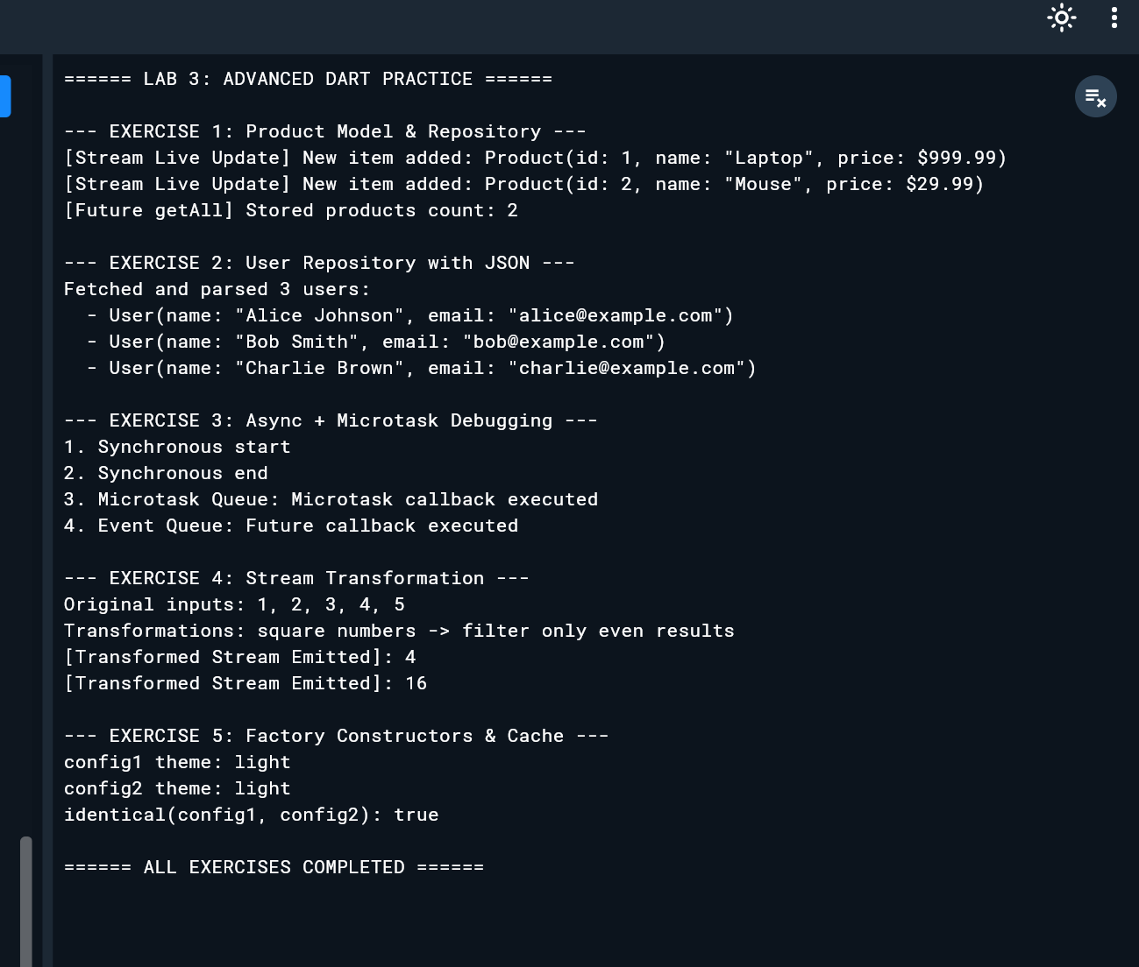
import 'dart:async';
import 'dart:convert';

// ============================================================================
// EXERCISE 1: Product Model & Repository (Future + Stream)
// ============================================================================
class Product {
final int id;
final String name;
final double price;

Product({required this.id, required this.name, required this.price});

@override
String toString() => 'Product(id: $id, name: "$name", price: \$$price)';
}

class ProductRepository {
final List<Product> _storage = [];
// Broadcast controller allows multiple listeners for real-time events
final StreamController<Product> _controller = StreamController<Product>.broadcast();

// Future-based retrieval simulating async database/network fetch
Future<List<Product>> getAll() async {
await Future.delayed(const Duration(milliseconds: 300));
return List.unmodifiable(_storage);
}

// Stream providing live notifications whenever a product is added
Stream<Product> liveAdded() => _controller.stream;

void addProduct(Product product) {
_storage.add(product);
_controller.add(product); // Emit the new item into the stream
}

void dispose() {
_controller.close();
}
}

Future<void> runExercise1() async {
print('--- EXERCISE 1: Product Model & Repository ---');
final repo = ProductRepository();

// Listen for live updates
final subscription = repo.liveAdded().listen((product) {
print('[Stream Live Update] New item added: $product');
});

// Add sample products
repo.addProduct(Product(id: 1, name: 'Laptop', price: 999.99));
repo.addProduct(Product(id: 2, name: 'Mouse', price: 29.99));

// Allow stream callbacks to flush
await Future.delayed(const Duration(milliseconds: 100));

// Fetch all products via Future
final allProducts = await repo.getAll();
print('[Future getAll] Stored products count: ${allProducts.length}');

await subscription.cancel();
repo.dispose();
print('');
}

// ============================================================================
// EXERCISE 2: User Repository with JSON Serialization
// ============================================================================
class User {
final String name;
final String email;

User({required this.name, required this.email});

// Factory constructor for deserializing JSON maps
factory User.fromJson(Map<String, dynamic> json) {
return User(
name: json['name'] as String,
email: json['email'] as String,
);
}

@override
String toString() => 'User(name: "$name", email: "$email")';
}

class UserRepository {
// Simulates fetching raw JSON string from a REST API endpoint
Future<List<User>> fetchUsers() async {
await Future.delayed(const Duration(milliseconds: 300));

const jsonString = '''
[
{"name": "Alice Johnson", "email": "alice@example.com"},
{"name": "Bob Smith", "email": "bob@example.com"},
{"name": "Charlie Brown", "email": "charlie@example.com"}
]
''';

final List<dynamic> decodedList = jsonDecode(jsonString);
return decodedList
.map((item) => User.fromJson(item as Map<String, dynamic>))
.toList();
}
}

Future<void> runExercise2() async {
print('--- EXERCISE 2: User Repository with JSON ---');
final userRepo = UserRepository();
final users = await userRepo.fetchUsers();

print('Fetched and parsed ${users.length} users:');
for (final user in users) {
print(' - $user');
}
print('');
}

// ============================================================================
// EXERCISE 3: Async + Microtask Debugging
// ============================================================================
Future<void> runExercise3() async {
print('--- EXERCISE 3: Async + Microtask Debugging ---');

// 1. Synchronous code runs first
print('1. Synchronous start');

// 2. Event queue task (Futures schedule work onto the event queue)
Future(() {
print('4. Event Queue: Future callback executed');
});

// 3. Microtask queue task (High priority queue)
scheduleMicrotask(() {
print('3. Microtask Queue: Microtask callback executed');
});

// 1. Synchronous code finishes
print('2. Synchronous end');

// Explanation:
// In Dart's event loop, the Microtask Queue has higher priority than the Event Queue.
// Before picking any new event from the Event Queue (like Future()), Dart drains
// the entire Microtask Queue. Hence, Microtasks always run before Future callbacks.

// Wait for queues to complete execution
await Future.delayed(const Duration(milliseconds: 200));
print('');
}

// ============================================================================
// EXERCISE 4: Stream Transformation
// ============================================================================
Future<void> runExercise4() async {
print('--- EXERCISE 4: Stream Transformation ---');

// 1. Stream of numbers 1 to 5
final numberStream = Stream.fromIterable([1, 2, 3, 4, 5]);

print('Original inputs: 1, 2, 3, 4, 5');
print('Transformations: square numbers -> filter only even results');

// 2. map() squares the value; 3. where() filters for even results
final transformedStream = numberStream
.map((n) => n * n) // [1, 4, 9, 16, 25]
.where((n) => n.isEven); // [4, 16]

// 4. Listen and print results
await for (final value in transformedStream) {
print('[Transformed Stream Emitted]: $value');
}
print('');
}

// ============================================================================
// EXERCISE 5: Factory Constructors & Cache (Singleton Pattern)
// ============================================================================
class Settings {
String theme = 'dark';
int refreshInterval = 30;

// Private named constructor prevents direct instantiation
Settings._internal();

// Static cached singleton instance
static final Settings _instance = Settings._internal();

// Factory constructor returns the cached instance
factory Settings() {
return _instance;
}
}

void runExercise5() {
print('--- EXERCISE 5: Factory Constructors & Cache ---');

// Request two instances
final config1 = Settings();
final config2 = Settings();

// Modify a property via the first reference
config1.theme = 'light';

print('config1 theme: ${config1.theme}');
print('config2 theme: ${config2.theme}'); // Reflects change because it points to the exact same object

// Verify memory reference equality
final isSameInstance = identical(config1, config2);
print('identical(config1, config2): $isSameInstance');
print('');
}

// ============================================================================
// MAIN ENTRY POINT
// ============================================================================
void main() async {
print('====== LAB 3: ADVANCED DART PRACTICE ======\n');

await runExercise1();
await runExercise2();
await runExercise3();
await runExercise4();
runExercise5();

print('====== ALL EXERCISES COMPLETED ======');
}

